

**Folding Shower Stool without Back**

**PR46034 / 10565**

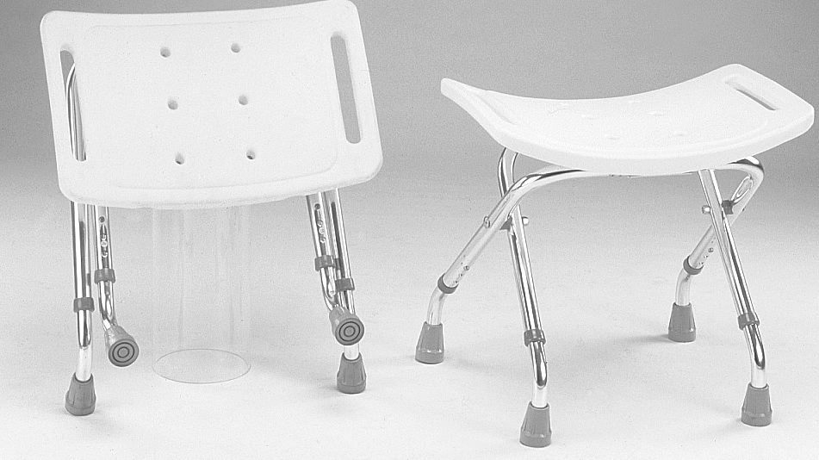



**Please inspect all parts carefully for cracks/breaks prior to use.**

**USER INSTRUCTIONS**

This product is for use in the shower.

## 10565 legsASSEMBLY INSTRUCTIONS

1. Put extension legs (1) into top leg frame (2).



2. The bottom of the shower stool is attached to the folding frame on one side. Attach the free leg securely into the “C” clamp

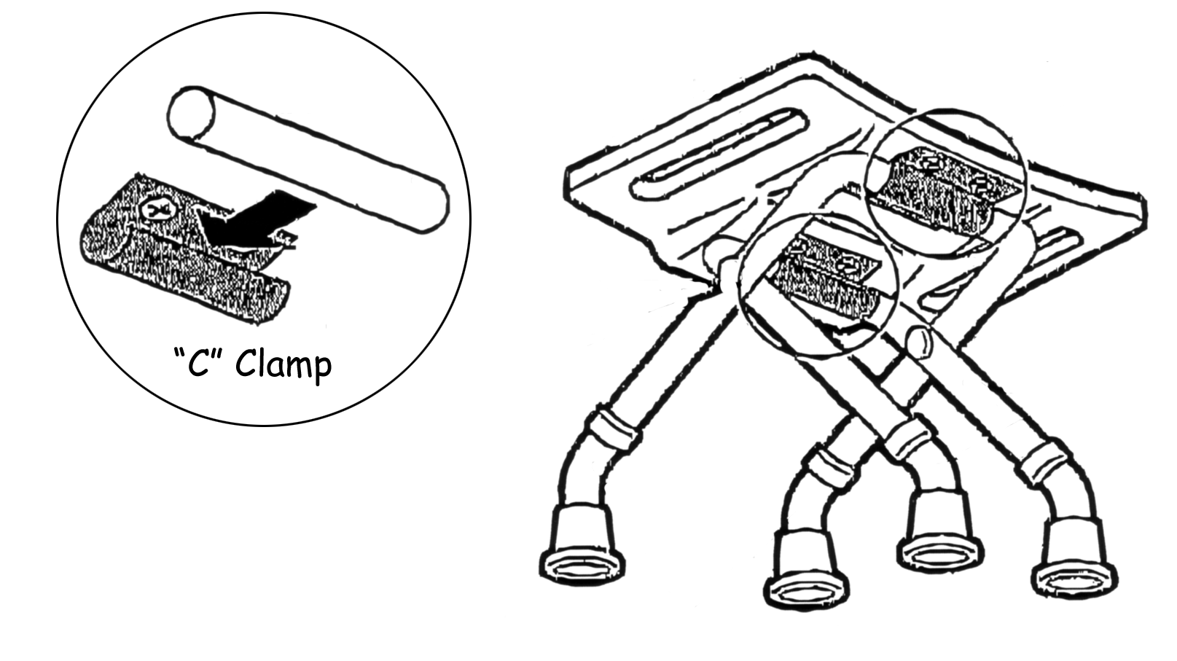

**Distributed By:**

**Able2 Europe B.V**. **Able2 UK**

Koperslagerij 15 www.able2.eu

4762 AR Zevenbergen

The Netherlands  **Able2 Iberia**

www.able2.nl www.able2.es

 Make sure all push buttons are aligned equally (same height adjustment)   
and all push-button pins are popped out all the way to assure a locked, secure position.

 DO NOT LEAN BACK as stool can tip over.

**CARE INSTRUCTIONS**

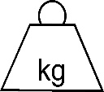Clean daily with mild soap and water; towel dry.

Made in Taiwan

Maximum

User Wt:

100