

Bath Board with Handle

PR46409 / 10440

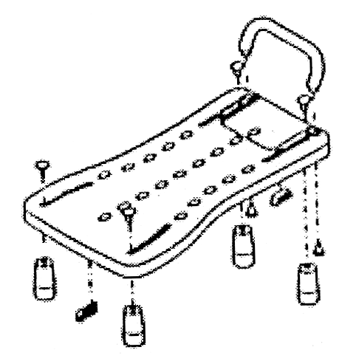
ASSEMBLY/USER INSTRUCTIONS

1. This product provides a comfortable seat for users who need to be sitting while bathing. Place this device flat on top of tub edges while using.

2. Adjust distance between footrests according to the width of bathtub. Tighten for ready use.

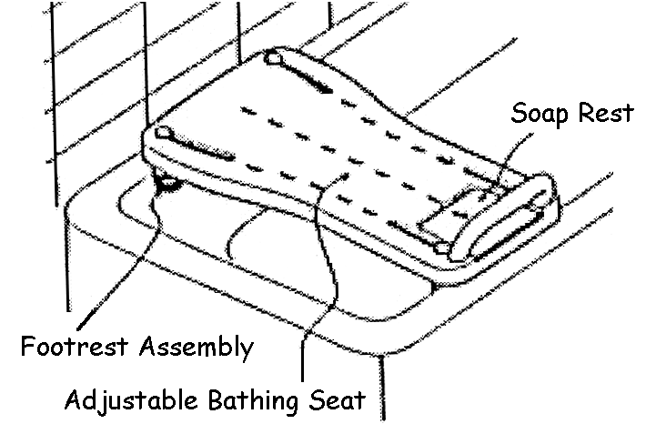

3. While assembling, adjust the distance between footrests according to bathtub size. Its distance fits most of the bathtubs available in the market.
Min. distance “A” – 390mm

Please inspect all parts carefully for cracks/breaks prior to use.

Max. distance “B” – 636mm
Distance “C” – 295mm
Distance “D” – 349mm
Distance “E” – 685mm
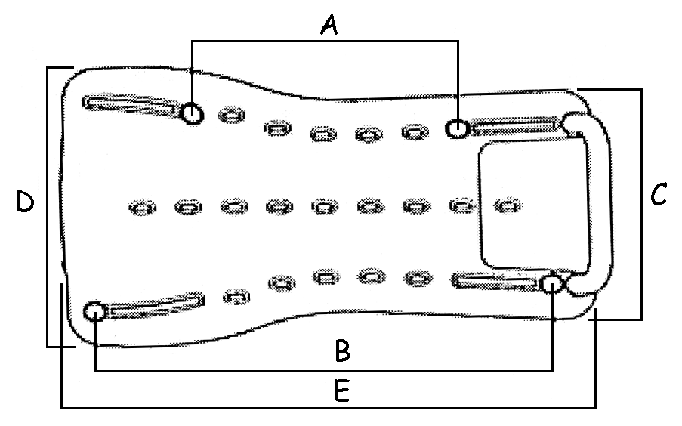

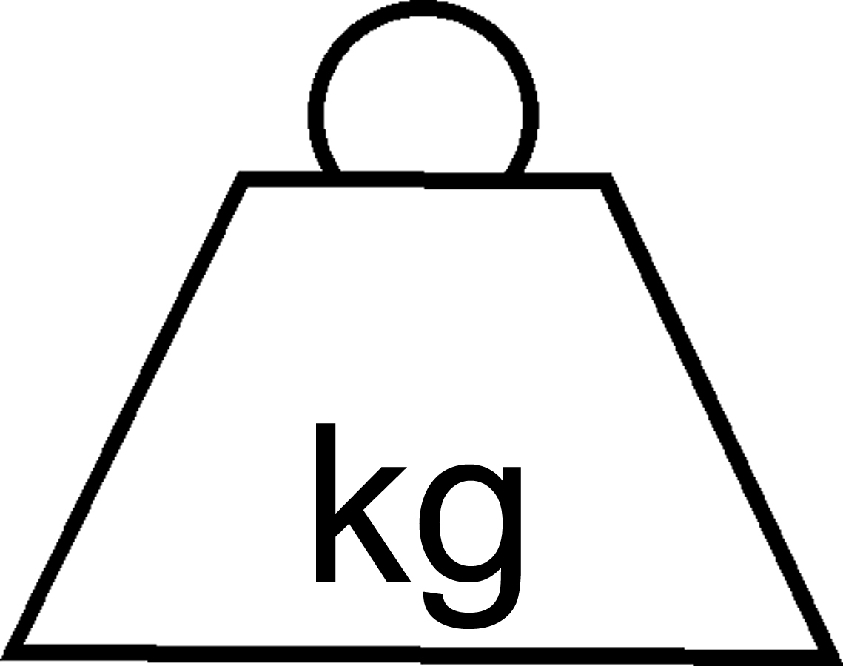
Maximum
User Wt:
100
4. The anti-slip rubber pad on the bottom of the product improves safety and does not damage the surface of the bathtub.

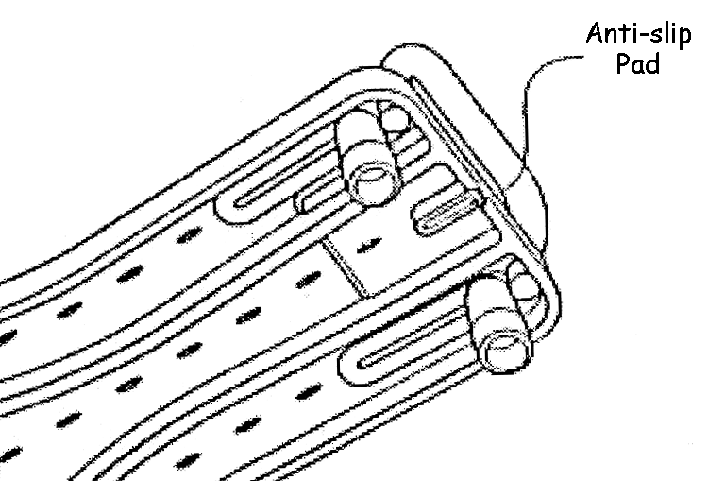
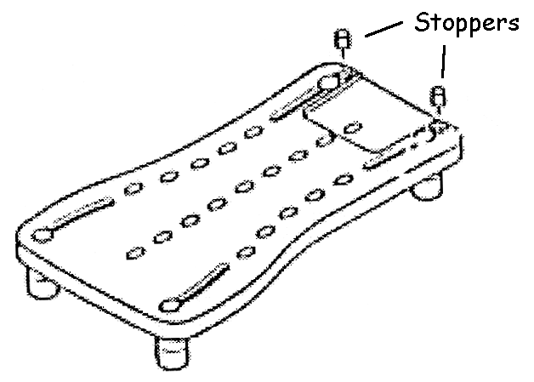
5. Insert stoppers in handle holes when handle is not attached.

 Do not use safety handle to assist in standing. Forced weight on one handle may
cause bath board to become unstable.

CARE/MAINTENANCE INSTRUCTIONS
Wash with clean water and mild soap; dry thoroughly.
Check that adjustable feet are tight against the tub edges before each use.


Made in Taiwan
Distributed By:
Able2 Europe B.V. Able2 UK
Koperslagerij 15 www.able2.eu
4762 AR Zevenbergen
The Netherlands Able2 Iberia
www.able2.nl www.able2.es

