SBR Professional manual 

This professional desk lamp is great for work but also for home if you want to illuminate a large work surface.

Before using the desk lamp, please read this short guide.

1. How to use:

Clamp the table clamp to the side of your desk. Insert the pin of the arm into the hole in the bracket. Connect the adapter to the lamp.

2. Usage:



3.1 On/Off button: 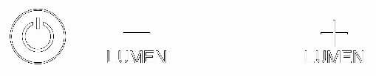

Press the next button, the lamp will now turn on or off.

3.2 Lumens -: 

Press the next button, the brightness goes down.

3.3 Lumen+ : 

Press the next button, the brightness goes up.

3.4 CCT -: 

Press the next button, the light color turns yellow;

3.5 CCT + : 

Press the next button, the light color turns white.

4. Important for safe use:

1) Only use the lamp indoors and not outdoors.

2) Ambient temperature-5℃~40℃.

3) Humidity level: ≤95% .

4) Never disassemble the lamp, this will void the warranty.

5.Parameters:

1) Voltage: AC 100-240V; 50/60Hz

2) Power:45W (540 PCS SMD LED)

6. If the external flexible cable of this lamp is damaged, it should only be replaced by the manufacturer or a similarly qualified person to avoid danger.

Finally, have fun with this beautiful desk lamp!