Manual SBR Deluxe 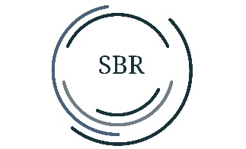

This LED desk lamp is great for at home, work, in a workshop or other activities.

Before using the Led lamp, please read this manual.

1: How to use:

Clamp the table clamp to the side of your desk. Insert the pin of the arm into the hole in the bracket. Connect the adapter to the lamp.

2: On and off:

The lamp can be turned on by pressing the power button once. Press 2x in a row to turn off the lamp.

3: Light color

Press the power switch

Press 1st time: LED CCT is 3000k

Press 2nd time: LED CCT is 4500k

Press 3rd time: LED CCT is 6000k (daylight)

Important: pause for 3 seconds after each CCT switchover.

4: Dimming

Want to dim the light? Then press and hold the power button. The light will come on brighter. Release the button and hold the power button again is and the light will dim.

5: Important for safe use

- Indoor use only

- Ambient temperature -5C to 40C

- Humidity +-95%

- Never disassemble the lamp

Parameters:

- Voltage: 100-240V 50/60Hz

- Power: 24W (182pcs SMD LED)

6: If the external flexible cable of this lamp is damaged, it should only be replaced by the manufacturer or a similarly qualified person to avoid danger.

Finally, have fun with this beautiful daylight lamp!