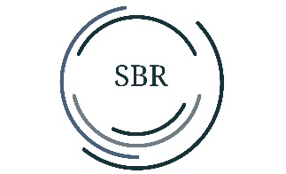
SBR Flex Desk Lamp
Turning it on/off: Plug in the adapter and press the power button at and the LED lights will come on. Press this button again and the lights will turn off.
The lamp maintains the settings as long as the adapter is plugged in.

Timer: Press the touch button at ,The red led light is now on. This means that the lighting automatically turns off after 30 minutes. Press this button again and the light now lights green. This means that the lighting automatically turns off after 60 minutes. Now press this button for the 3rd time and the timer function is now disabled.

Light color: To change the light color press this button : 3000K/ 3500K / 4000K / 5000K / 6000K.
Dimming: Swipe your finger from left to right across the dots. The LED lights will now come on brighter. Swiping from right to left makes the illumination weaker. You can adjust the brightness in 7 steps from 10%~100%.

On the back near the adapter jack is the USB connection. Here you can, for example, charge your smartphone or power bank. Output: 5V 2.1A.

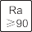
High CRI Eye protection 5 Modes CCT 7 Levels Dimming

Auto-timer Touch Control Quick-Charge Multi-angle
Specifications:
Power: 12W
Lumen: 600
Lux at 30cm: 1200
CRI: 90+
Dimming: 7 steps
Kelvin: 3000-6000K
Input: 100~240V 50/60Hz 1.5Amax
Output: 12V⎓1A
USB output: 5V⎓2.1A
Temperature: -20°C~40°C
Weight: 1.2Kg

Important for safe use !

- This lamp can only be used indoors
- Ambient temperature -5C to 40C
- Humidity +-95%
- Never take the lamp apart or look directly into the LED lights.
- Power: 12W
If the lamp is damaged, it should only be repaired by the manufacturer or a similarly qualified person to avoid danger.

