SBR To Go manual 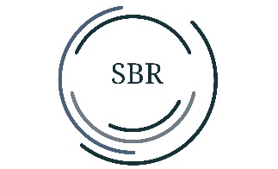

This LED desk lamp is great for at home, work, in a workshop or other activities.

Before using the SBR To Go, please read this manual.

1: How to use:

Slide the switch at the bottom of the base to ON.

2: Charging:

Plug the Micro USB cable into the back of the SBR To Go lamp. The USB end can be inserted into a laptop or USB adapter. When the lamp is charging, a small red light illuminates under the micro USB connector. When the battery is full, the red light goes out.

There is a touch button on the back, which can be used to turn the nightlight on and off.

Turning on/off

The lamp can be turned on by pressing the large on/off button on the front of the lamp once.

3: Light color

Press the on/off switch again and the light color changes.

Press 1st time: LED CCT is 6000k (daylight)

Press 2de time: LED CCT is 4500k

Press 3de time: LED CCT is 2700k

4: Dimming

Want to dim the light? Then press and hold the power button. The light will dim. Release the button and hold the power button is again and the light will turn brighter.

5: Important for safe use

- Indoor use only

- Ambient temperature -5C to 40C

- Humidity +-95%

- Never take the lamp apart or look directly into the LED lights.

- Power: 5W

6: If the lamp is damaged, it should only be repaired by the manufacturer or a similarly qualified person to avoid danger.

Finally, have fun with this beautiful daylight lamp!