Overbed Tables

PR60196 / 12216, PR60197 / 12215

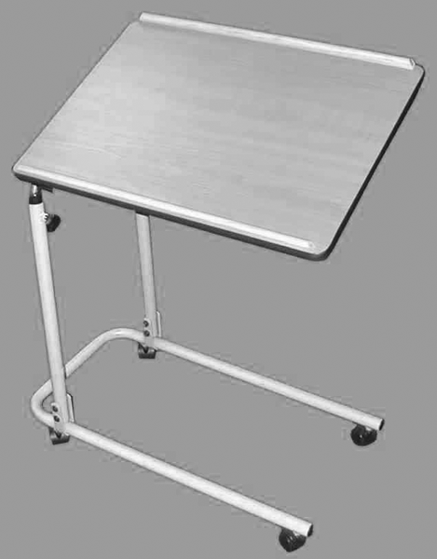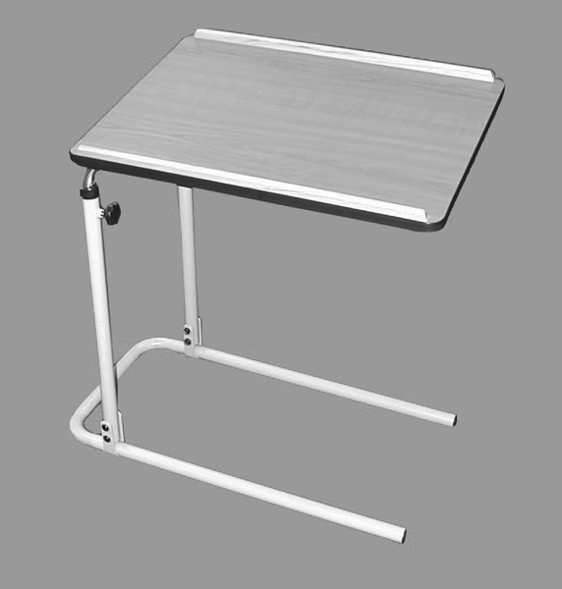

PR60196 / 12216 PR60197 / 12215

Please inspect all parts carefully for cracks/breaks prior to use.

USER INSTRUCTIONS

This product is NOT designed to be used as a walking aid – do not place your weight onto the table top. Do not place more than 20 lbs onto the table top. Do not lean on the suspended end of the table top at any time. This may tip over the entire overbed table.

Do not put cigarettes on the table top as it may catch fire.

Make sure the tilt control knob and height control knob are tightened at all times. Otherwise, items on top of the table may tip over.

frame assembly
Distributed By:

Able2 Europe B.V. Able2 UK
Koperslagerij 15 www.able2.eu
4762 AR Zevenbergen
The Netherlands Able2 Iberia
www.able2.nl www.able2.es

Place the two legs attached to the base frame in the upright position and secure in position using the washer, nuts and bolts provided. For each leg, place a washer onto a bolt and push the bolt from the outside through the hole in the leg frame, then place another washer onto the other end of the bolt and screw on a nut.

TOP assembly
Loosen the height adjustment knobs on the base leg frames and insert the table top chrome legs into the base legs. The table height and angle can be adjusted. Be sure to tighten the adjustment knobs securely.

caster brakes
To engage caster brakes, press down on the break lever on the wheel until it clicks into position. To release, lift up lever.

Made in Taiwan

